Supplementary Materials

Supplementary table
Table S1. Antimicrobial effect of farnesal and farnesol against Streptococcus mutans.
Compound | Minimum inhibitory concentration (μg/mL) | Minimum bactericidal concentration (μg/mL)
Farnesal | 14 | 112
Farnesol | 28 | 112
Chlorhexidine Digluconate | ≤ 3.5 | 14

Supplementary figures

Figure S1
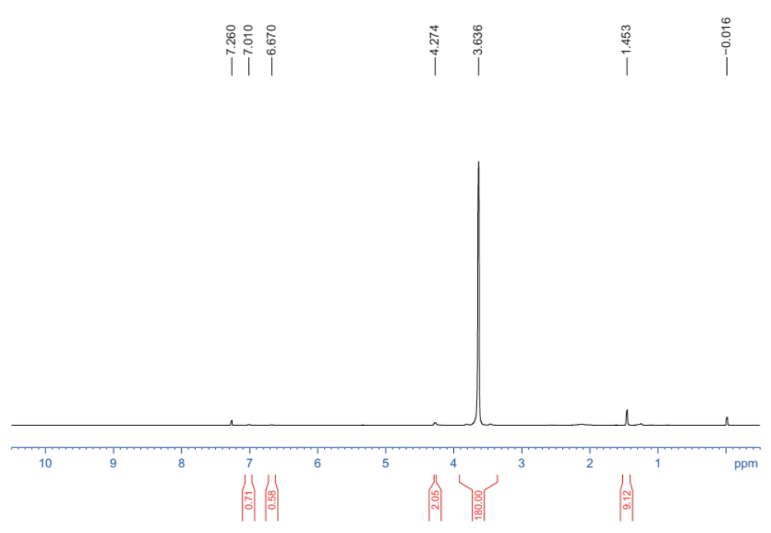
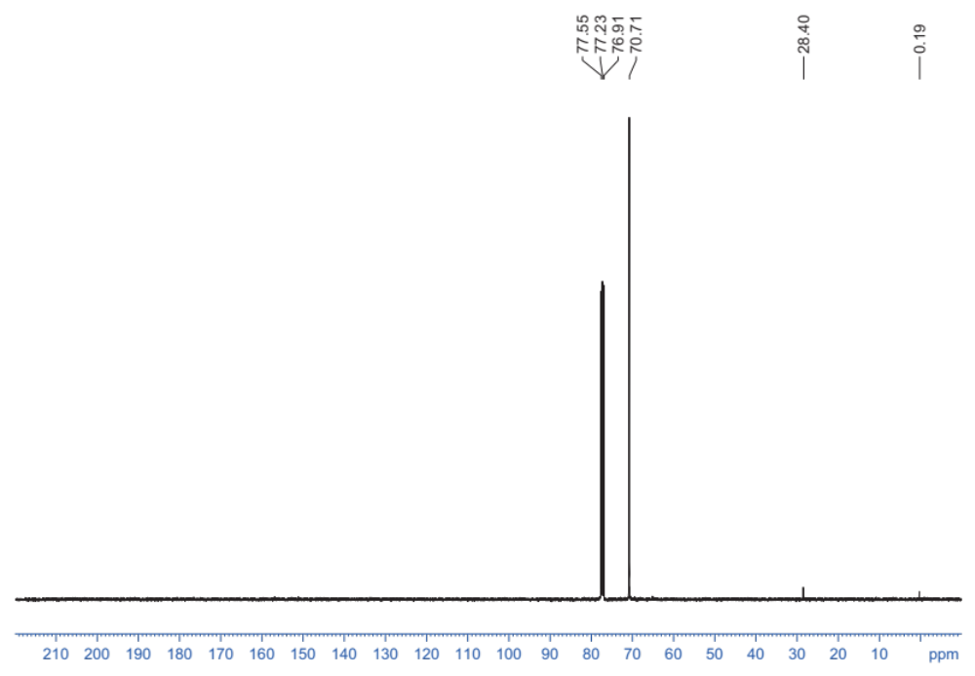
Figure S1. ¹H NMR and ¹³C NMR spectra of synthetic compound 1: tert-butyl 2-(2-(2-hydroxyethoxy)acetyl)hydrazine-1-carboxylate (HO-PEG-NHNH-Boc).

Figure S2
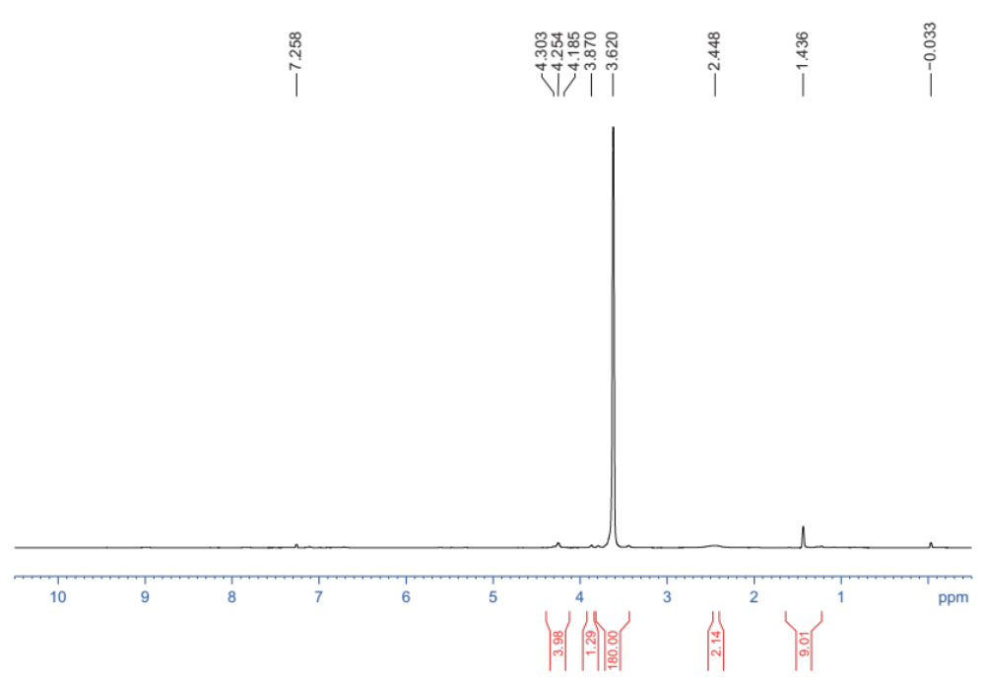
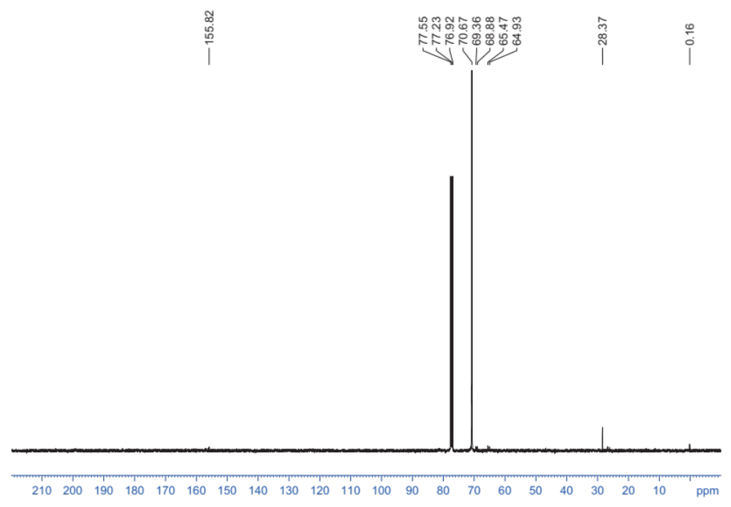
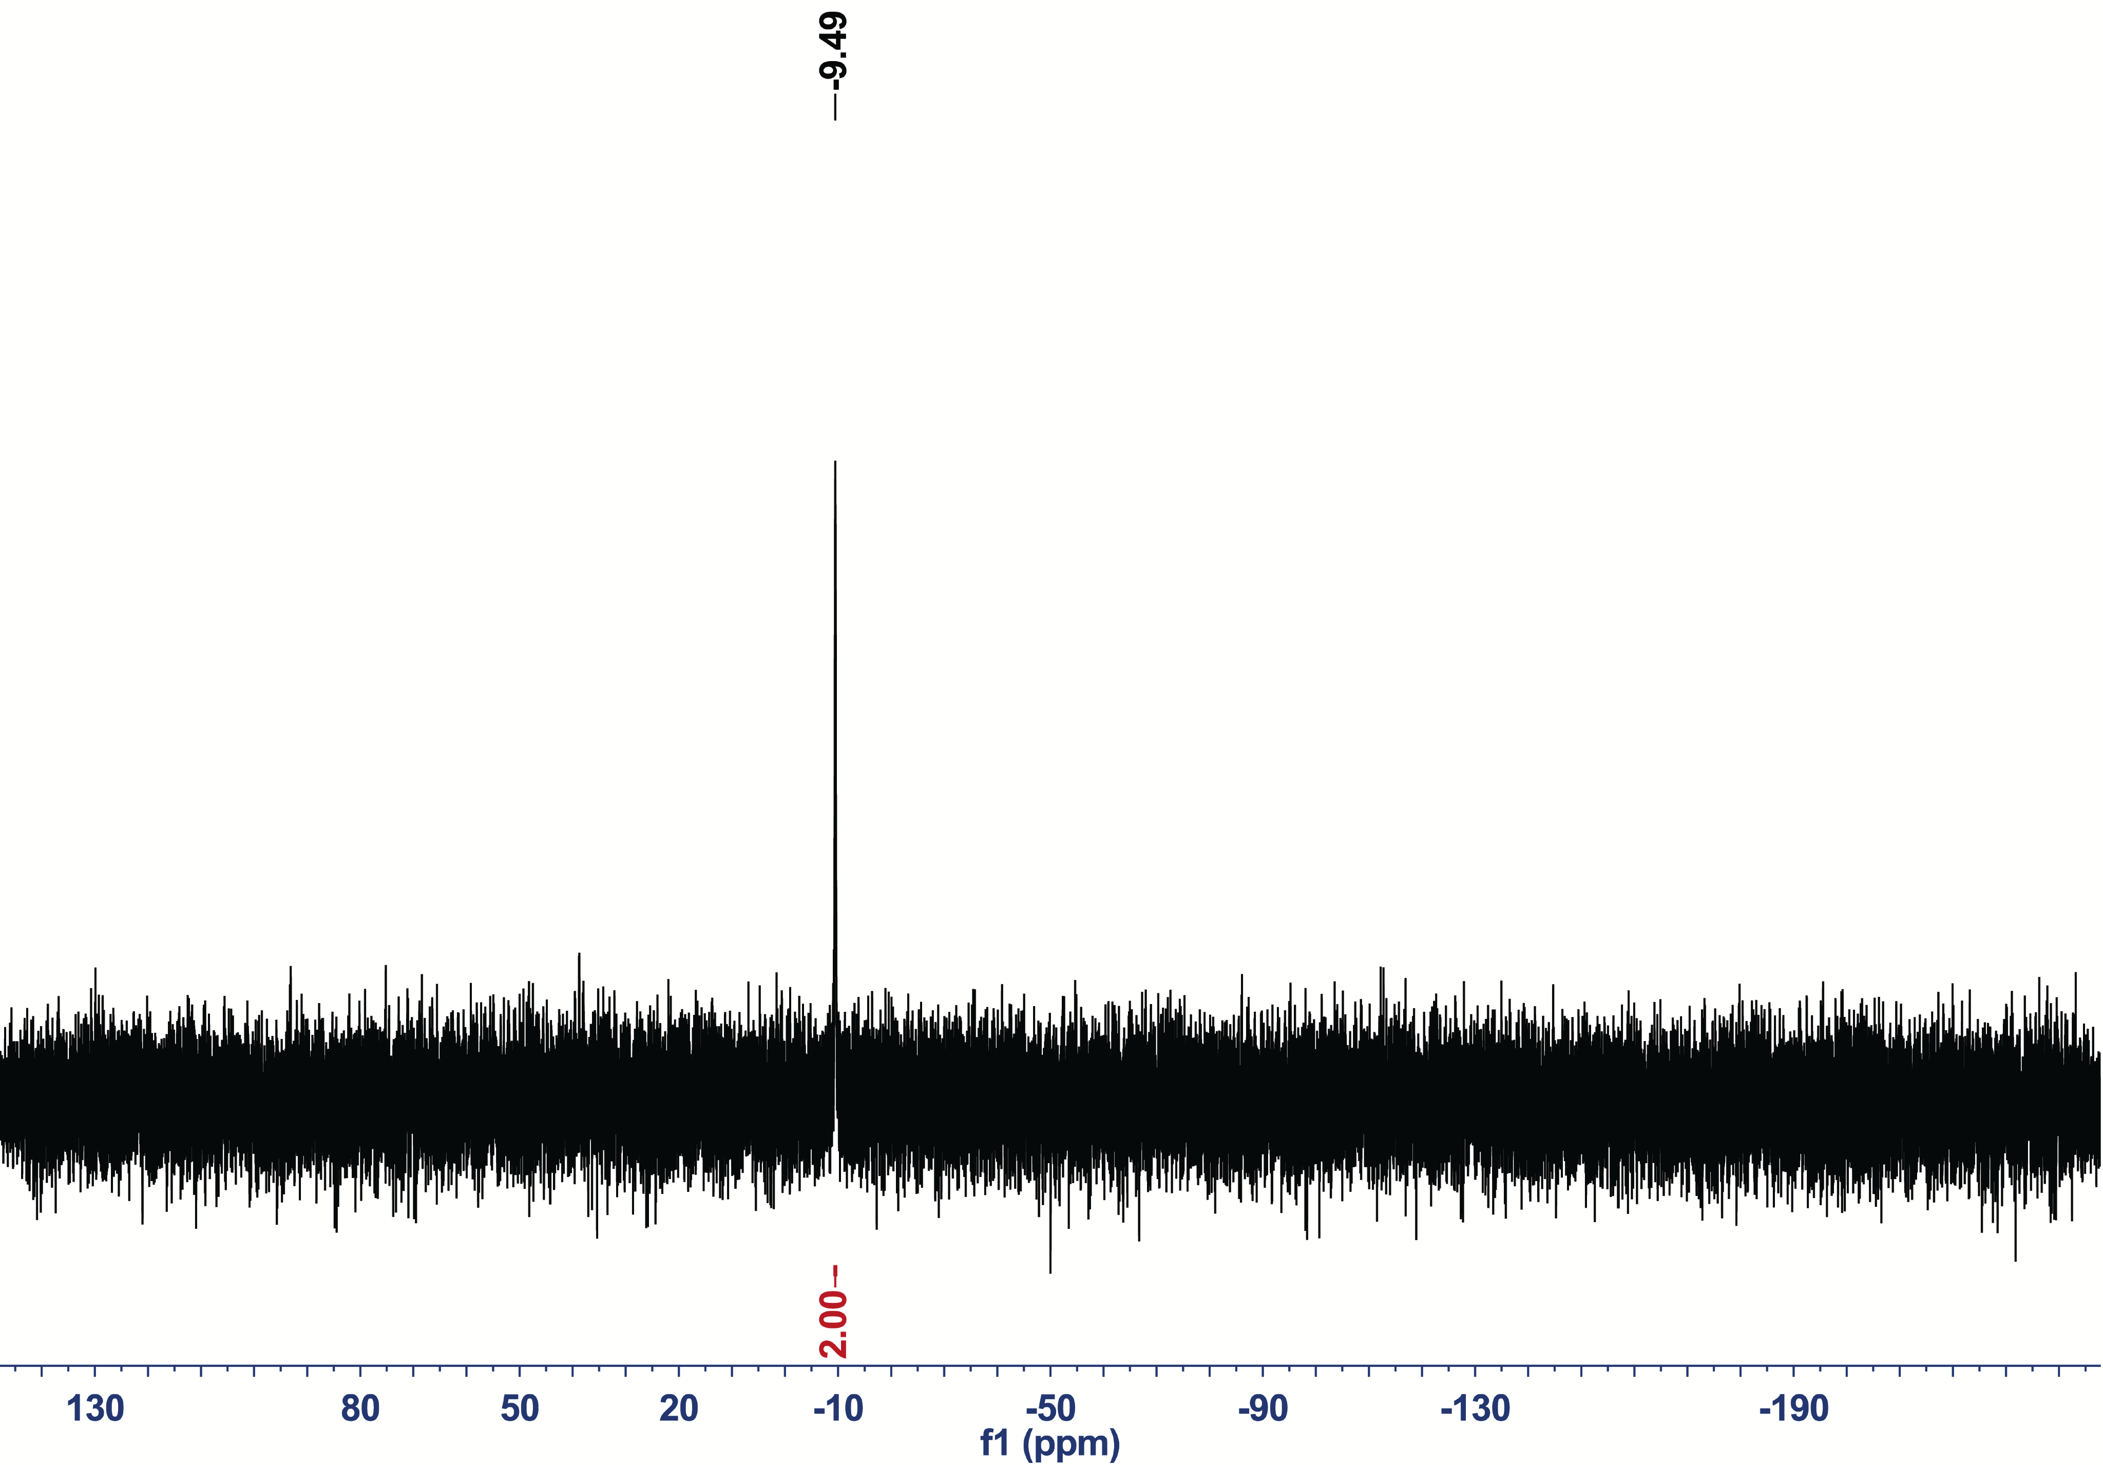
Figure S2. ¹H NMR, ¹³C NMR and ³¹P NMR spectra of synthetic compound 2: sodium 2,2-dimethyl-4,7,13-trioxo-3,9,12-trioxa-5,6-diazatetradecan-14-yl hydrogen diphosphate (PPi-PEG-NHNH-Boc).

Figure S3
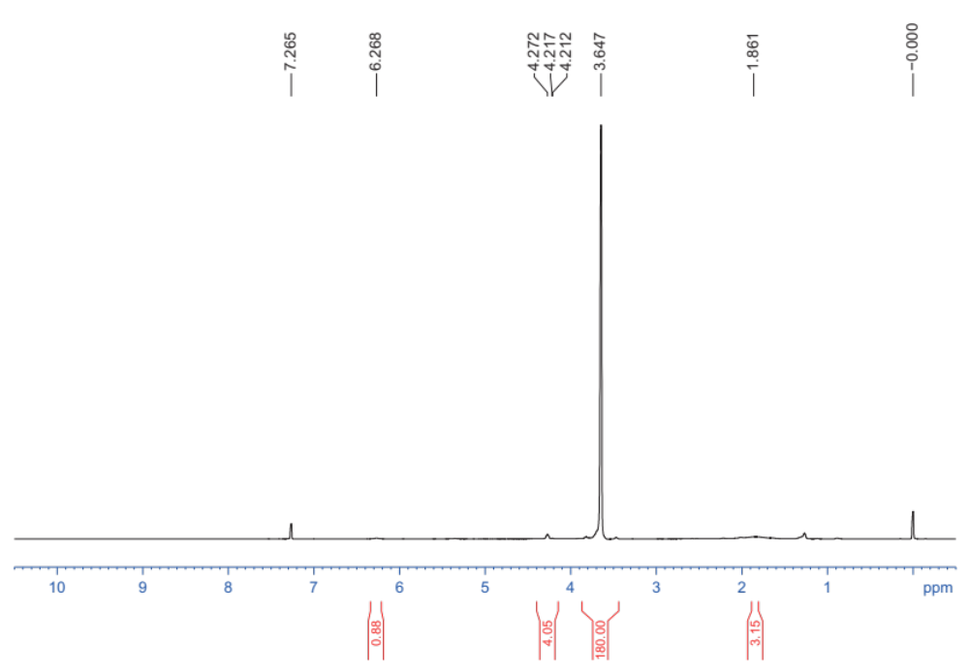
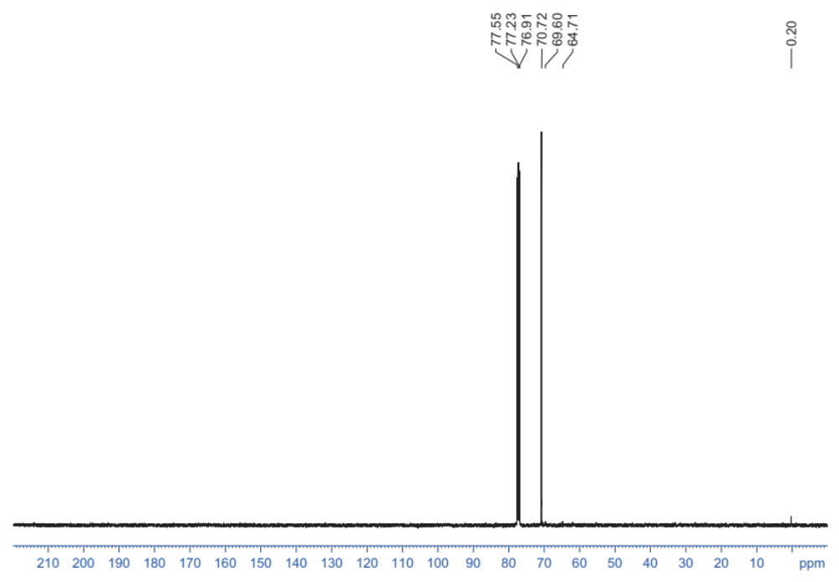
Figure S3. ¹H NMR and ¹³C NMR spectra of synthetic compound 3: sodium 2-(2-(2-hydrazinyl-2-oxoethoxy)ethoxy)-2-oxoethyl hydrogen diphosphate (PPi-PEG-NHNH₂).

Figure S4
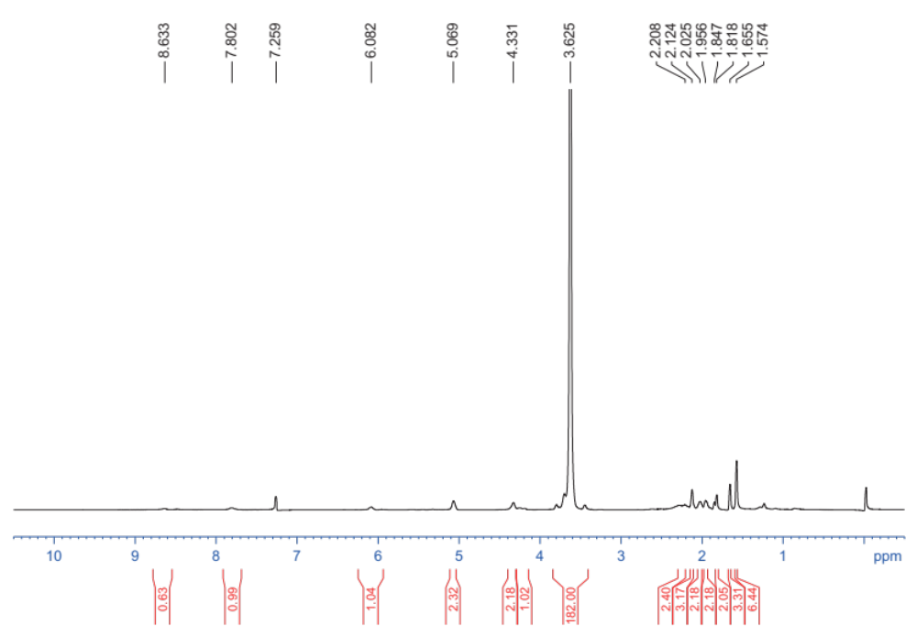
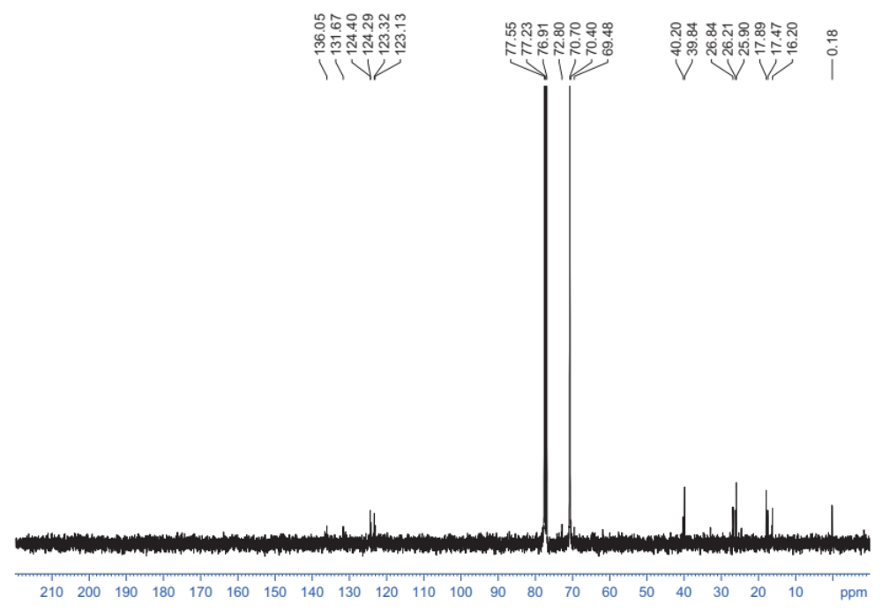
Figure S4. ¹H NMR and ¹³C NMR spectra of synthetic compound 4: sodium 2-oxo-2-(2-(2-oxo-2-(2-((2E,6E)-3,7,11-trimethyldodeca-2,6,10-trien-1-ylidene)hydrazinyl)ethoxy)ethoxy)ethyl hydrogen diphosphate (PPi-PEG-hyd-Far).

Figure S5
Figure S5. In vitro characterization of Blank PMs and PPi-Far-PMs. Critical micelle concentration of Blank PMs (A) and PPi-Far-PMs (B) was determined according to the concentration at the crossover point in the plots of the fluorescence intensity ratio (I₃₈₃/I₃₇₃) against the logarithm of micelle concentration (μg/mL).

Figure S6
Figure S6. Effects of different treatments on the microarchitecture of molars in rats. Animals were treated with 15% ethanol, farnesol, farnesal, blank PMs, Far-PMs. After 5 weeks, the molars of rats were analyzed using high-resolution micro-computed tomography to obtain three-dimensional reconstruction pictures of the smooth-surface molars (A) and sulcal-surface molars (B).

